

Submitted By:
Muhammad Zain Rasheed – 2025-CYS-153
Assignment:
Lab No. 2
Submitted To:
Sir Mubashir

For the fulfillment of,
Object-Oriented Programming Lab
Department of Computer Engineering
University of Engineering and Technology, Lahore

Task No. 1: The Geometry Calculator (Operators & Math)
Objective: Use Math methods and arithmetic operators.
• Create a program that stores the radius of a circle as a double.
• Calculate the area ($Area = \pi \times r^2$). Use Math.PI and Math.pow().
• Print the result. Then, use Type Casting to print the area as a whole integer.
Solution:
import java.util.Scanner;
public class Main{
public static void main(String[] args){
Scanner radi = new Scanner(System.in);
System.out.print("Please Enter the Radius of a Circle = ");
double radius = radi.nextDouble();
double area = Math.PI * Math.pow(radius,2);
System.out.println("The Area of Circle whose Radius is "+radius+ " is "+area);
int fin = (int) area;
System.out.println("Using Manual Type Casting, the Area of Circle in Integer is "+fin);
}
}

Output:
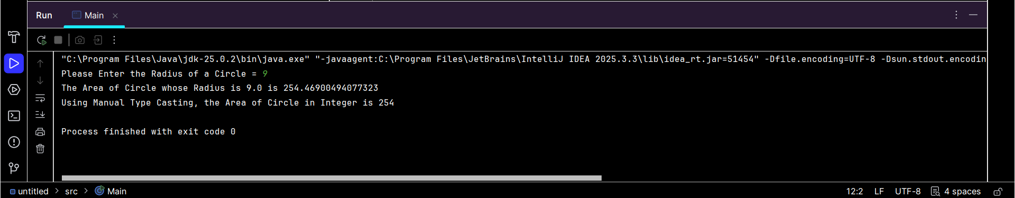

Task No. 2: String Analysis Tool (Strings)
Objective: Manipulate and analyze text data.
• Create a String variable fullName containing your first and last name.
• Print the length of the string.
• Convert the name to all uppercase.
• Use indexOf( ) to find the position of the space between the names.
Solution:
import java.util.Scanner;
public class Main{
public static void main(String[] args) {
Scanner name = new Scanner(System.in);
System.out.print("Please Enter your Full Name in Lower Case = ");
String fullname = name.nextLine();
System.out.println("The Length of your Full Name is = "+fullname.length());
System.out.println("Your Full Name in Upper Case is = "+fullname.toUpperCase());
int findspace = fullname.indexOf(" ");
while(findspace != -1){
System.out.println("There is a Space in Your Full Name at Index "+findspace);
findspace = fullname.indexOf(" ",findspace + 1);
}
}
}

Output:
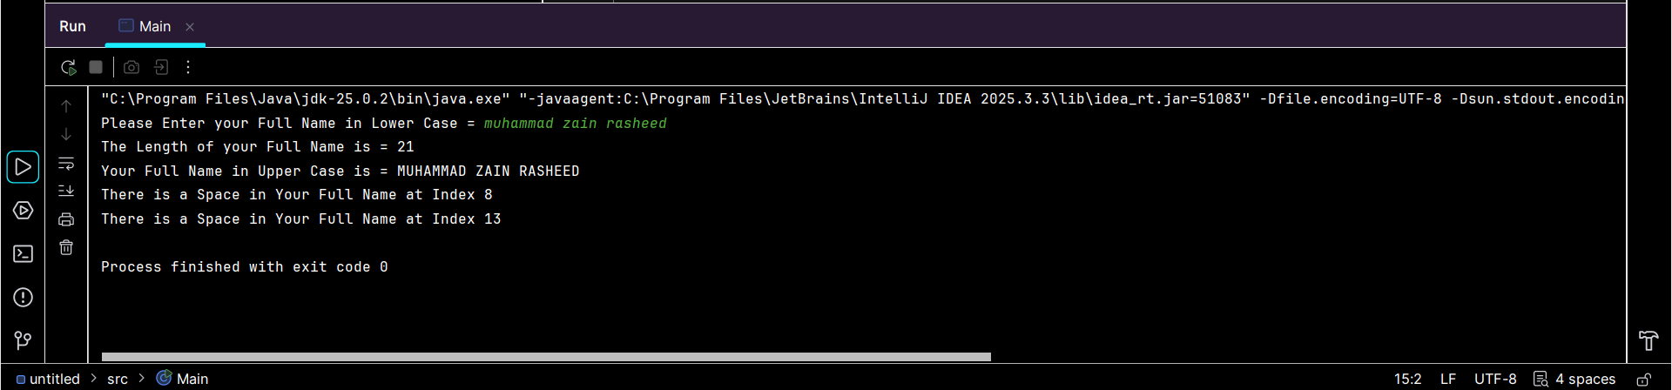
Task No. 3: Automatic Grade Converter (Type Casting)
Objective: Practice Narrowing Casting and Output.
• Declare a double variable percentage = 85.99.
• Manually cast this percentage into an int.
• Print: "Your raw score is: 85.99% but your rounded grade is: 85%"
Solution:
public class Main{
public static void main(String[] args){
double percentage = 85.99;
int finals = (int) percentage;
System.out.print("Your raw score is: "+percentage+"% but your rounded grade is: "+finals+"%");
}
}

Output:
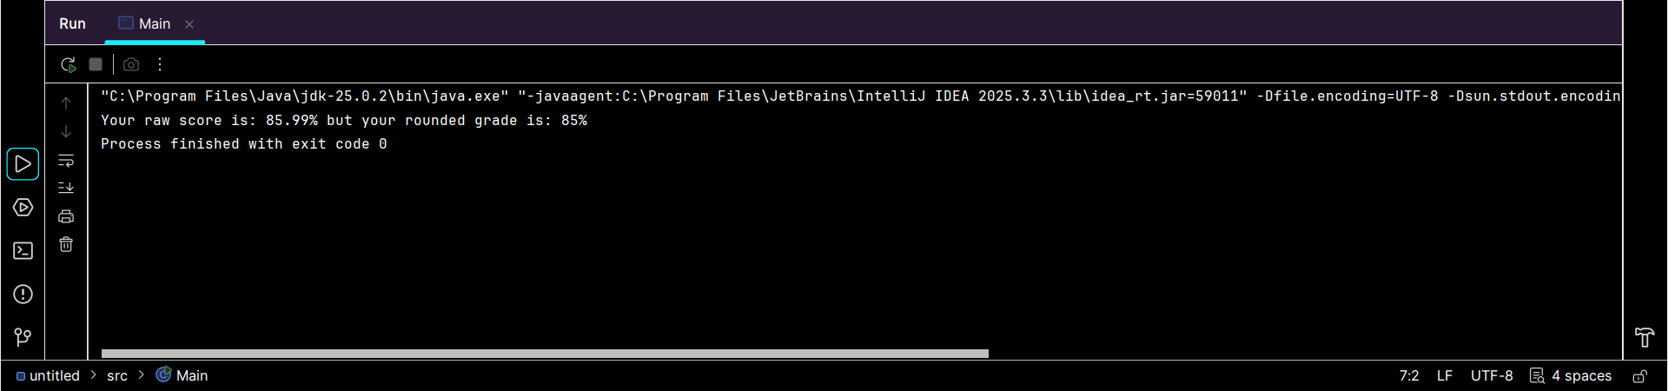

Task No. 4: The Logical Gatekeeper (Logical Operators)
Objective: Use &&, ||, and !.
• Create two boolean variables: hasID and isOver18.
• Write an if statement that prints "Access Granted" only if both are true.
• Write another statement that prints "Special Guest" if they have an ID OR they are over 18.
Solution:
import java.util.Scanner;
public class Main{
public static void main(String[] args){
Scanner var = new Scanner(System.in);
System.out.print("Have You get any ID or Not (True or False) = ");
boolean hasID = var.nextBoolean();
System.out.print("Are You Above 18 or Not (True or False) = ");
boolean isOver18 = var.nextBoolean();
if(hasID && isOver18){
System.out.print("Access Granted");
}else {
System.out.print("Special Guest");
}
}
}

Output:
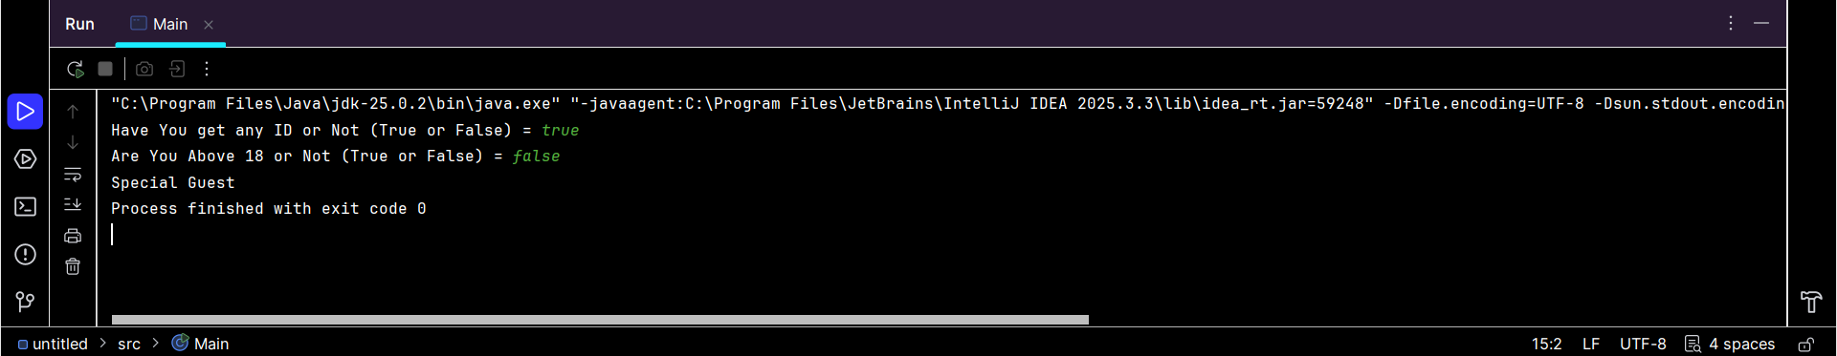

Task No. 5: Random Number Matcher (Math & Booleans)
Objective: Use Math.random() and comparisons.
• Generate a random number between 1 and 10. Hint: Use (int)(Math.random() * 11).
• Declare a variable userGuess = 5.
• Print true if the random number matches the guess, otherwise print false.
Solution:
public class Main{
public static void main(String[] args){
int randomNum = (int) (Math.random()*11);
int userGuess = 5;
System.out.println("The Random Number is = "+randomNum);
System.out.println("And the User Guess is = "+userGuess);
if (userGuess == randomNum){
System.out.print("True");
}else {
System.out.print("False");
}
}
}

Output:
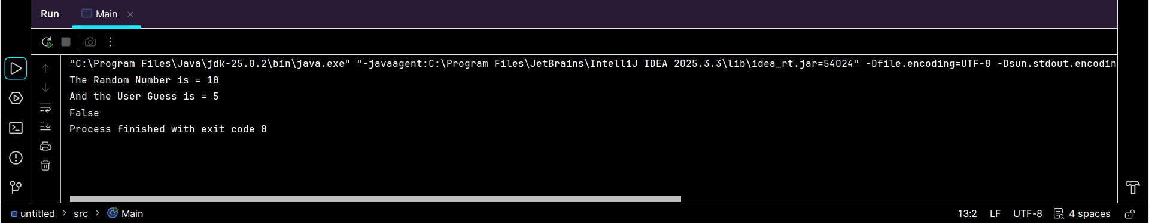

Task No. 6: Personalized Greeting (Strings & Concatenation)
Objective: Use different methods of string joining.
• Create variables for greeting, firstName, and lastName.
• Use the + operator to join them for one output.
• Use the .concat() method to join them for a second output.
Solution:
public class Main{
public static void main(String[] args){
String greeting = "Assalam-o-Alaikum! ";
String firstName = "Muhammad Zain ";
String lastName = "Rasheed";
System.out.println("First Output = "+greeting+firstName+lastName);
String again = greeting.concat(firstName).concat(lastName);
System.out.print("Second Output = "+again);
}
}

Output:
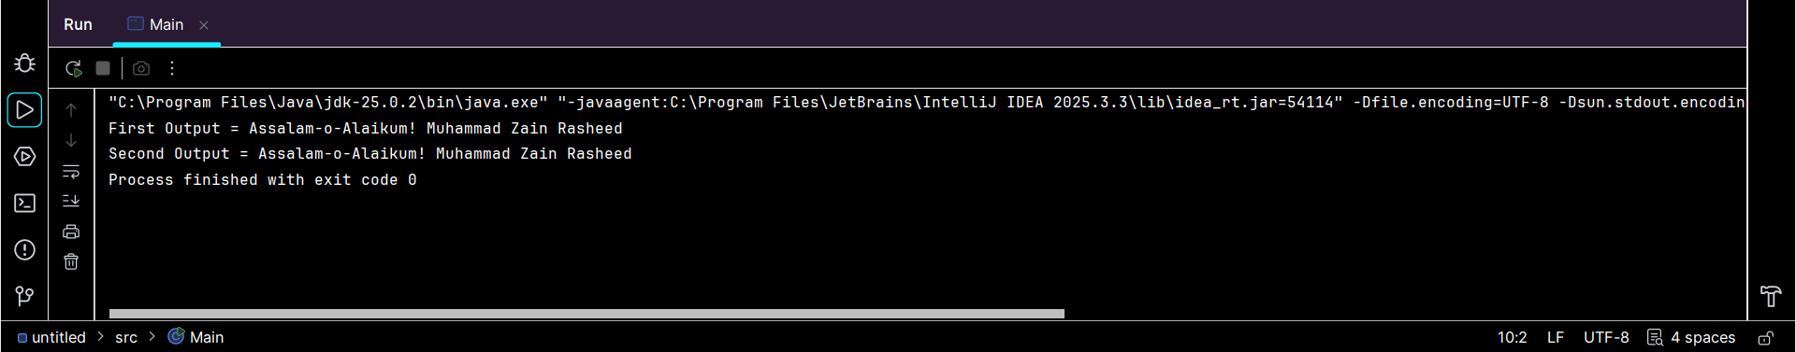

Task No. 7: Time-of-Day Identifier (If...Else If)
Objective: Use conditional chains.
• Store an int variable hour (0 to 23).
• If hour is between 5 and 11, print "Good Morning".
• Else if hour is between 12 and 17, print "Good Afternoon".
• Else if hour is between 18 and 23, print "Good Evening".
• Use else to handle any other numbers as "Invalid Hour".
Solution:
import java.util.Scanner;
public class Main{
public static void main(String[] args){
Scanner input = new Scanner(System.in);
System.out.print("Enter Hour from 0 to 23 = ");
int hour = input.nextInt();
if(hour>=5 && hour<=11){
System.out.println("Good Morning");
}else if (hour>=12 && hour<=17){
System.out.println("Good Afternoon");
}else if (hour>=18 && hour<=23){
System.out.println("Good Evening");
}else{
System.out.println("Invalid Hour");
}
}
}

Output:
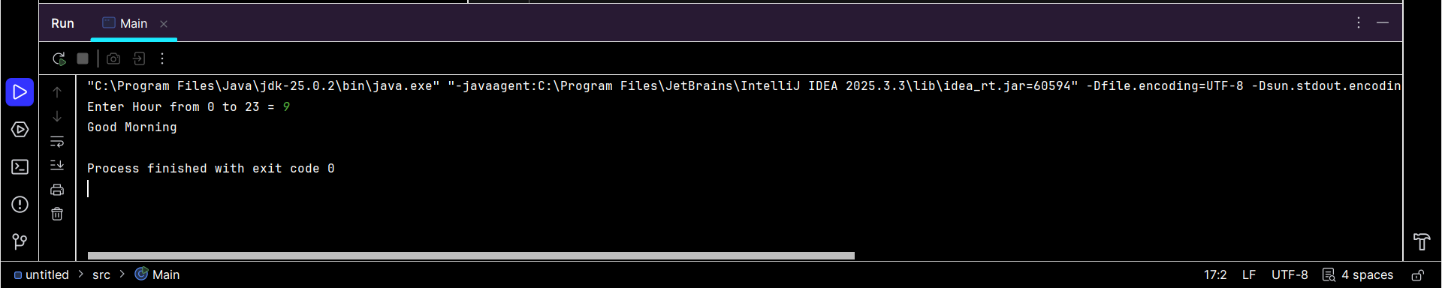
Task 8: The Currency Switcher (Switch Case)
Objective: Practice multi-way branching.
• Create a variable String currency = "USD".
• Use a switch statement to print the full name of the currency:
- "USD" -> "United States Dollar"
- "GBP" -> "British Pound"
- "EUR" -> "Euro"
- Default -> "Unknown Currency"
Solution:
import java.util.Scanner;
public class Main {
public static void main(String[] args) {
Scanner paise = new Scanner(System.in);
System.out.print("Enter Currency (Like USD,GBP,EUR) = ");
String currency = paise.nextLine();
String fullForm;
switch (currency) {
case "USD":
fullForm = "United States Dollar";
break;
case "GBP":
fullForm = "British Pound";
break;
case "EUR":
fullForm = "Euro";
break;
default:
fullForm = "Unknown Currency";
break;
}
System.out.println("The Full Name of the currency " +currency+" is " + fullForm+".");
}
}

Output:
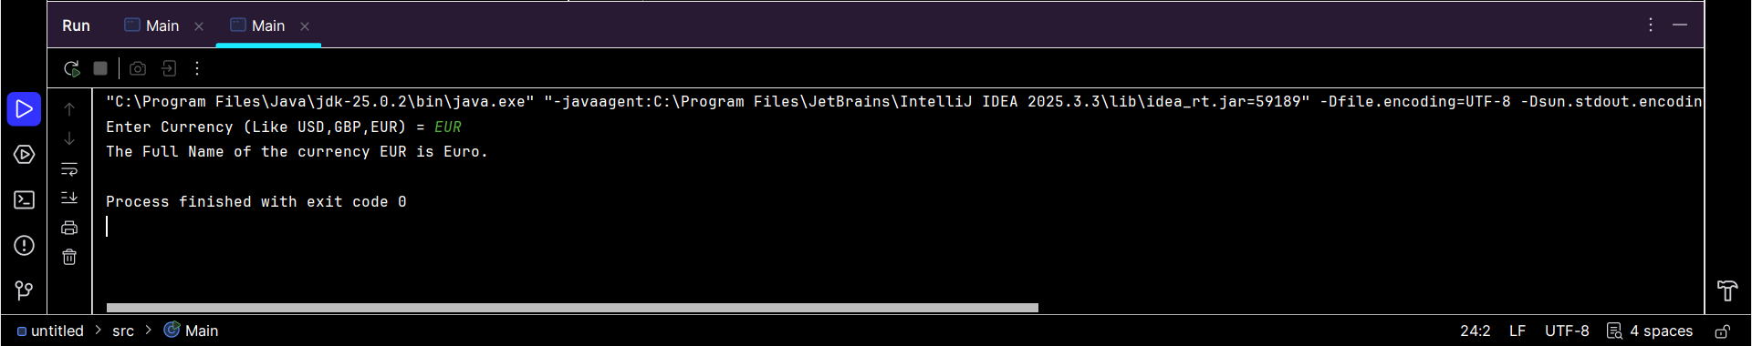

Task 9: Comparison & Increment Lab (Operators)
Objective: Understand how values change.
• Declare int x = 10 and int y = 20.
• Use a comparison operator to print if x is not equal to y.
• Apply the increment operator ++ to x.
• Print the new value of x and check if it is now greater than 10.
Solution:
public class Main{
public static void main(String[] args){
int x = 10;
int y = 20;
if (x != y){
System.out.println("Hello World !!!");
}
System.out.println("Original value of x = "+x);
x++;
System.out.println("Value of x After Increment of 1 = "+x);
if (x>10){
System.out.println("x is greater than 10");
}else{
System.out.println("x is not greater than 10");
}
}
}

Output:
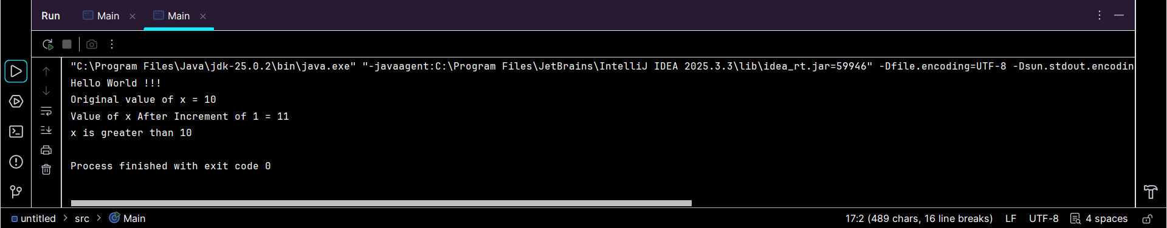

The End

